**HOW TO IMPORT SKIN/ HOMEPAGE LAYOUT:**

* **Step 01:** Choose and open the demo data file of homepage or skin you want to use:

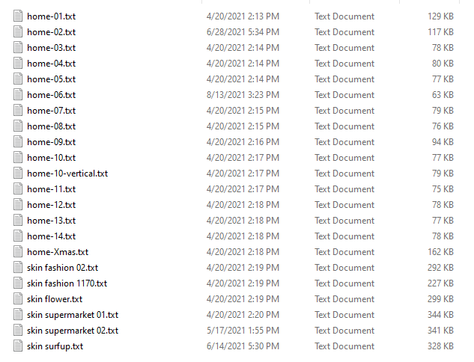

* **Step 02:** Copy all of data in file

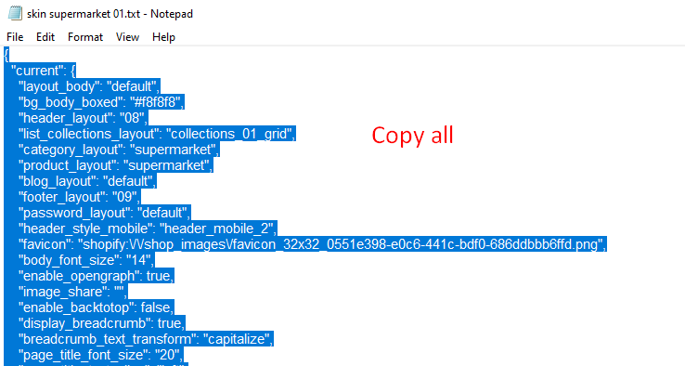

* **Step 03:** Go to Theme Source => Edit code => Search file “settings_data.json”

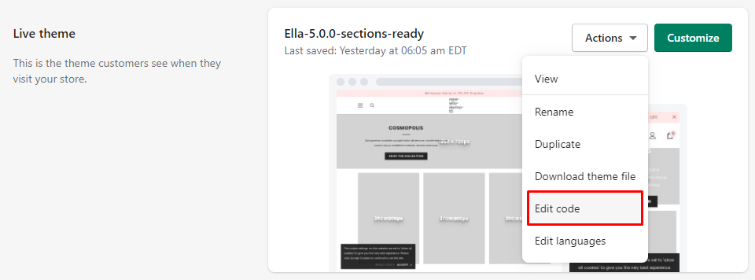

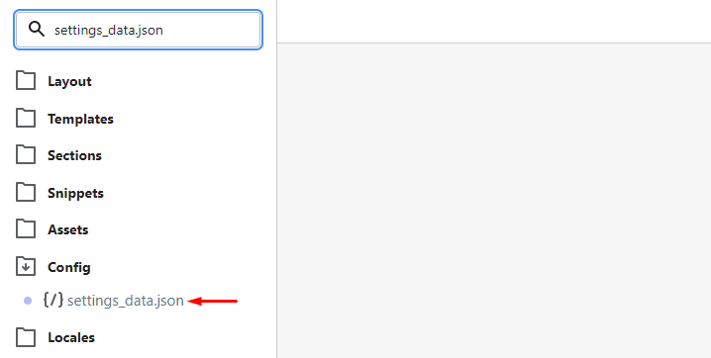

* **Step 04:** Delete all current data in this file and Paste the data you just copied in **Step 02**

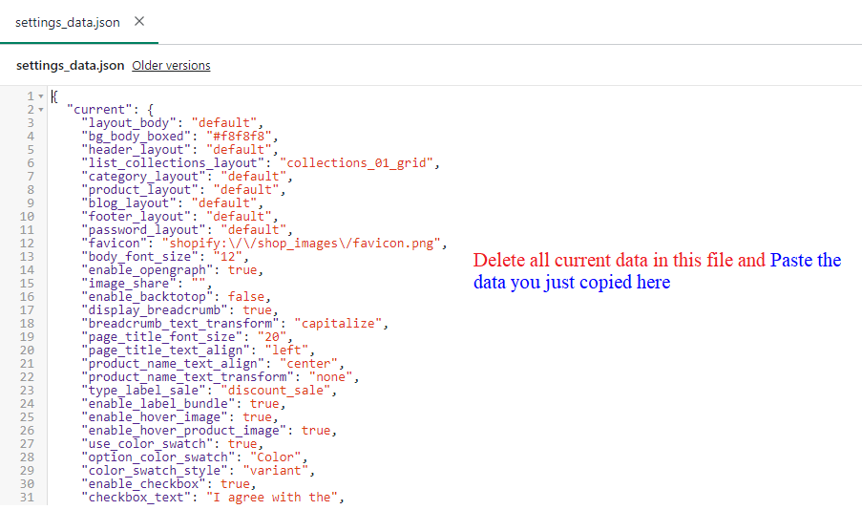

**Here is another instruction in Documentation you can refer:**

<http://themes.halothemes.com/marketplace/shopify-ella-documentation/Read_me.html#!/settings_data>